ITN Practice Skills Assessment
CCNAv7 Introduction to Networks: CS Department router, LAB 124-C LAN and LAB 214-A LAN, IPv4/IPv6 dual stack
This document walks through the assessment the same way it was configured: the subnetting design first, then each device with its screenshot, an explanation of the commands, and the mistakes that came up. A check list and a clean copy of the configuration are at the end.

1. What the assessment asks for
The topology has one router, CS Department, with two LANs off it: LAB 124-C (switch LAB 124-C Switch, hosts 124-1 and 124-5) and LAB 214-A (switch LAB 214-A Switch, host 214-1 and a Server). The LAB 124-C Switch is locked and cannot be configured or reached in this activity, so all the work on the left side is host addressing only. The right side, LAB 214-A, additionally needs the switch itself configured for remote management over Telnet.
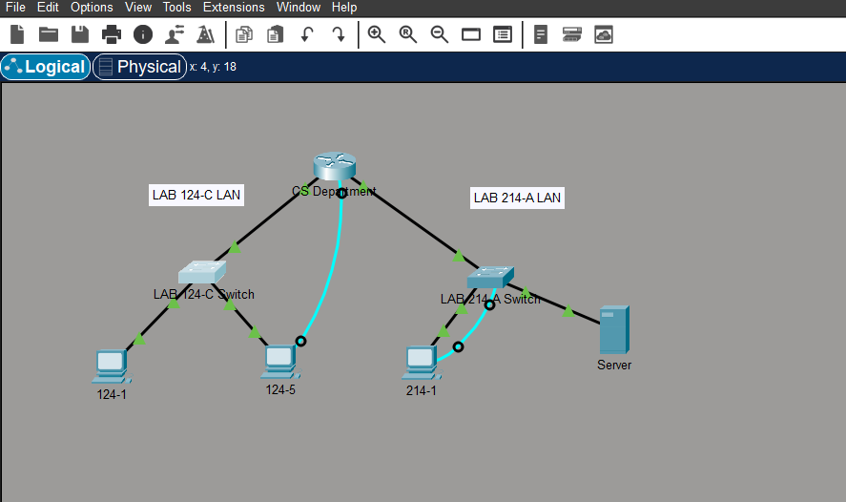
Figure 1. Topology: CS Department router between LAB 124-C LAN and LAB 214-A LAN.
The graded skills are the design and calculation of an IPv4 addressing scheme, IPv4 and IPv6 interface addressing, initial router hardening, secure remote management (SSH on the router, Telnet on the switch), and addressing the hosts and server with both IPv4 and IPv6.

Router requirements
- Hostname CS-Department, an encrypted privileged exec password, secured console and VTY lines, a minimum password length of 10, passwords encrypted in the config file, and a MOTD banner.
- In-band management restricted to the protocol more secure than Telnet (SSH), with a 1024-bit RSA key, and local login with user netadmin, secret Cisco_CCNA7.
- Both Gigabit interfaces configured with the calculated IPv4 addresses and the IPv6 addresses from the table below, with the link-local address on each set to fe80::1, and both interfaces documented with a description.

LAB 214-A Switch requirements
- Telnet management enabled, with VLAN 1 as the management SVI, addressed from the subnetting plan, and reachable from other networks (so it needs a default gateway).

Hosts and server
- IPv4 addresses from the subnetting plan and the IPv6 addresses given directly in the addressing table, with the router link-local address used as the IPv6 default gateway.

2. Working out the addressing scheme
The instructions build the scheme in two passes over 192.168.1.0/24, and the screenshots confirm both passes were carried out correctly.

Pass 1: 30 hosts per subnet
30 usable hosts needs 5 host bits (2^5 - 2 = 30), which is a /27, 32 addresses per block, mask 255.255.255.224.
# | Network | Usable hosts | Broadcast | Assigned to
1 | 192.168.1.0/27 | .1 – .30 | .31 | —
2 | 192.168.1.32/27 | .33 – .62 | .63 | —
3 | 192.168.1.64/27 | .65 – .94 | .95 | —
4 | 192.168.1.96/27 | .97 – .126 | .127 | LAB 124-C LAN
5 | 192.168.1.128/27 | .129 – .158 | .159 | broken into pass 2, below

Subnet 4 (192.168.1.96/27) goes to LAB 124-C. The highest host address in it, 192.168.1.126, goes on the router's G0/0, which matches the default gateway shown in the 124-1 and 124-5 host screenshots.

Pass 2: 14 hosts per subnet, inside subnet 5
14 usable hosts needs 4 host bits (2^4 - 2 = 14), a /28, 16 addresses per block, mask 255.255.255.240. Subnet 5 from pass 1 (192.168.1.128/27, addresses .128–.159) splits into two of these:
# | Network | Usable hosts | Broadcast | Assigned to
5a | 192.168.1.128/28 | .129 – .142 | .143 | (unused in this activity)
5b | 192.168.1.144/28 | .145 – .158 | .159 | LAB 214-A LAN

The second of the two new subnets, 192.168.1.144/28, goes to LAB 214-A. The highest host, 192.168.1.158, goes on the router's G0/1; the second highest, 192.168.1.157, goes on the switch's VLAN 1 SVI; the remaining addresses (.145, .146, ...) go on the host and server. All three match the screenshots.

Completed addressing table
Device | Interface | IPv4 address / mask | IPv6 address | Default gateway
CS-Department | G0/0 | 192.168.1.126 /27 | 2001:db8:acad:a::1/64, link-local fe80::1 | N/A
CS-Department | G0/1 | 192.168.1.158 /28 | 2001:db8:acad:b::1/64, link-local fe80::1 | N/A
LAB 214-A Switch | VLAN 1 (SVI) | 192.168.1.157 /28 | — | 192.168.1.158
124-1 | NIC | 192.168.1.97 /27 | 2001:db8:acad:a::ff/64 | 192.168.1.126 / fe80::1
124-5 | NIC | 192.168.1.98 /27 | 2001:db8:acad:a::15/64 | 192.168.1.126 / fe80::1
214-1 | NIC | 192.168.1.145 /28 | 2001:db8:acad:b::ff/64 | 192.168.1.158 / fe80::1
Server | NIC | 192.168.1.146 /28 | 2001:db8:acad:b::15/64 | 192.168.1.158 / fe80::1

The IPv6 addresses and the link-local override on both router interfaces were given directly in the assessment's addressing table, not calculated; only the IPv4 side needed the subnetting above.

3. Host and server addressing
All four end devices are set to static addressing, matching the table above. IPv6 uses the fixed address from the assessment sheet plus fe80::1 as the gateway, which is the link-local address configured on the router.
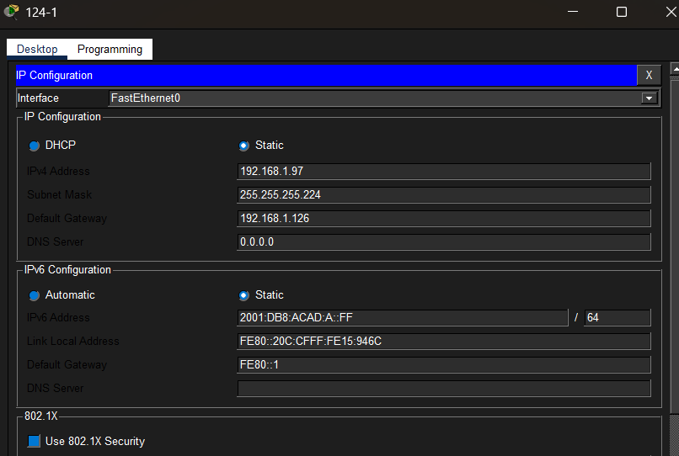
Figure 2. 124-1: static IPv4 192.168.1.97/27 and IPv6 2001:db8:acad:a::ff/64, gateway 192.168.1.126 / fe80::1.
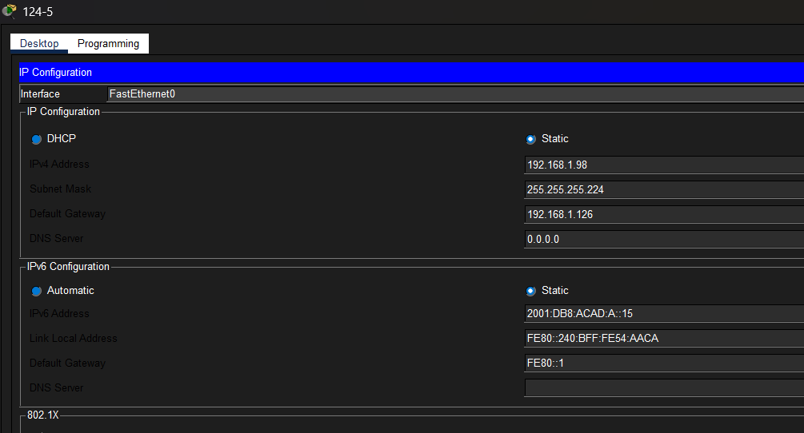
Figure 3. 124-5: static IPv4 192.168.1.98/27 and IPv6 2001:db8:acad:a::15/64, same gateways as 124-1.
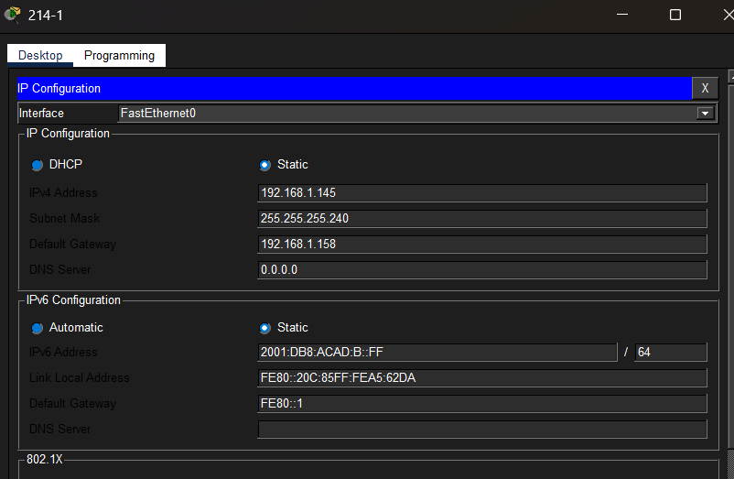
Figure 4. 214-1: static IPv4 192.168.1.145/28 and IPv6 2001:db8:acad:b::ff/64, gateway 192.168.1.158 / fe80::1.
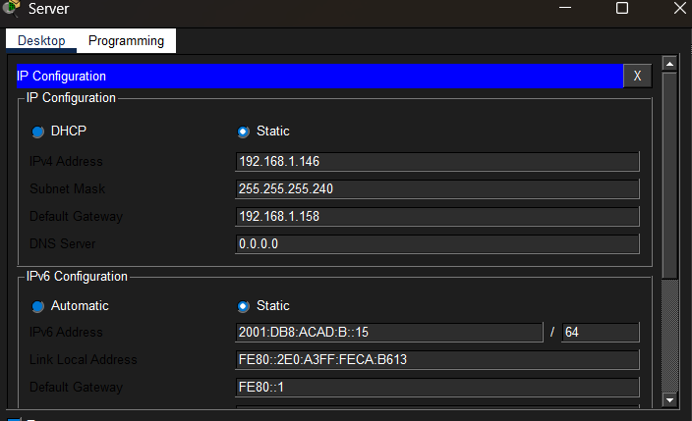
Figure 5. Server: static IPv4 192.168.1.146/28 and IPv6 2001:db8:acad:b::15/64, same gateways as 214-1.
124-1 and 124-5 share a gateway because they are both on the LAB 124-C /27. 214-1 and the Server share a different gateway because they are on the LAB 214-A /28. The IPv6 link-local gateway, fe80::1, is the same string on both LANs because the assessment sheet has it reused on both router interfaces; that is unusual outside a lab, but it is what the addressing table specifies and it works because link-local addresses only need to be unique on their own link.

4. CS-Department router
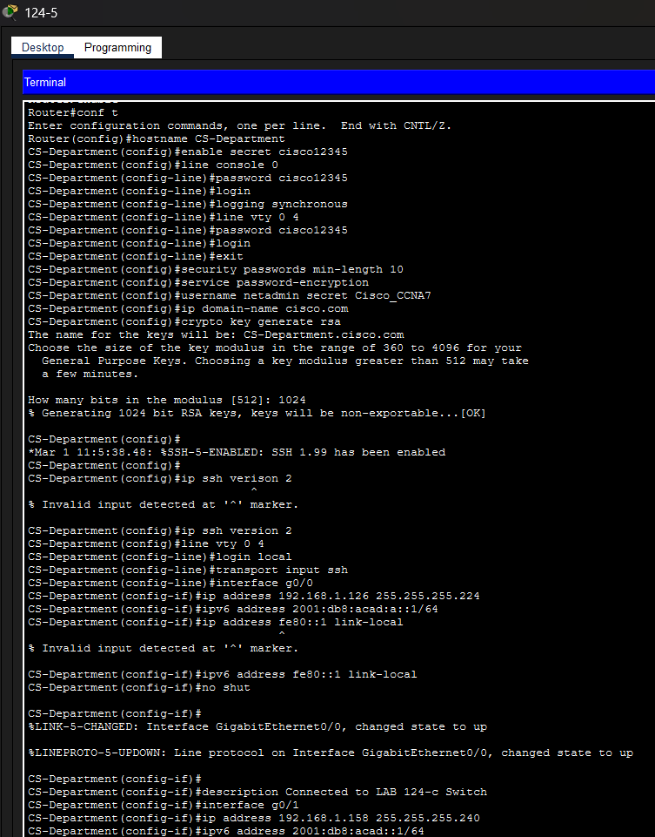
Figure 6. CS-Department: initial hardening, SSH setup, and the G0/0 / G0/1 addressing.

Initial hardening
- hostname CS-Department sets the name the assessment asks for.
- enable secret cisco12345 is the encrypted privileged exec password. It happens to satisfy the later security passwords min-length 10 rule (10 characters), but that rule only enforces length on passwords set after it, so it is safer to configure security passwords min-length 10 first, before any password.
- Console and VTY get password cisco12345 plus login. logging synchronous on the console line is not required by the assessment; it just stops log messages from interrupting typed commands.
- service password-encryption scrambles the line and username passwords in the running/startup config so show running-config does not display them in clear text. It does not strengthen the password itself, which is why enable secret (already hashed) is still used for the privileged exec password rather than enable password.

SSH access
- username netadmin secret Cisco_CCNA7 creates the local account the assessment specifies.
- ip domain-name cisco.com and crypto key generate rsa (1024 bits) are both required before SSH will run; the key name shown, CS-Department.cisco.com, is built from the hostname and domain name together.
- ip ssh version 2 was first typed as ip ssh verison 2 (transposed letters) and rejected as invalid input, then retyped correctly.
- On line vty 0 4, login local and transport input ssh together mean: authenticate against the local user database, and accept SSH connections only. Telnet is not accepted on these lines, which satisfies "only the protocol more secure than Telnet".
One thing to check: the assessment topology and the VTY line range in the config screenshot don't fully agree. The initial password/login block was applied to line vty 0 4 (5 lines), which is the normal default. That is fine to leave as is, since the assessment does not ask for a specific number of VTY lines.

Interfaces
- G0/0: ip address 192.168.1.126 255.255.255.224, ipv6 address 2001:db8:acad:a::1/64, then ipv6 address fe80::1 link-local. The first attempt at the link-local address was typed as ip address fe80::1 link-local (missing the v6) and was rejected; the corrected line uses ipv6 address. description Connected to LAB 124-c Switch documents the link, and no shut brings the interface up.
- G0/1: ip address 192.168.1.158 255.255.255.240, then ipv6 address 2001:db8:acad:1::1/64.
That last line has a typo worth fixing: the address is 2001:db8:acad:1::1/64, using the digit 1 where the addressing table specifies the letter b (2001:db8:acad:b::1/64). As typed, G0/1 is not in the same IPv6 network as 214-1 and the Server, so IPv6 between the router and the LAB 214-A LAN will not work until this is corrected. See the check list below for this and the other items still to confirm on this interface.

5. LAB 214-A Switch
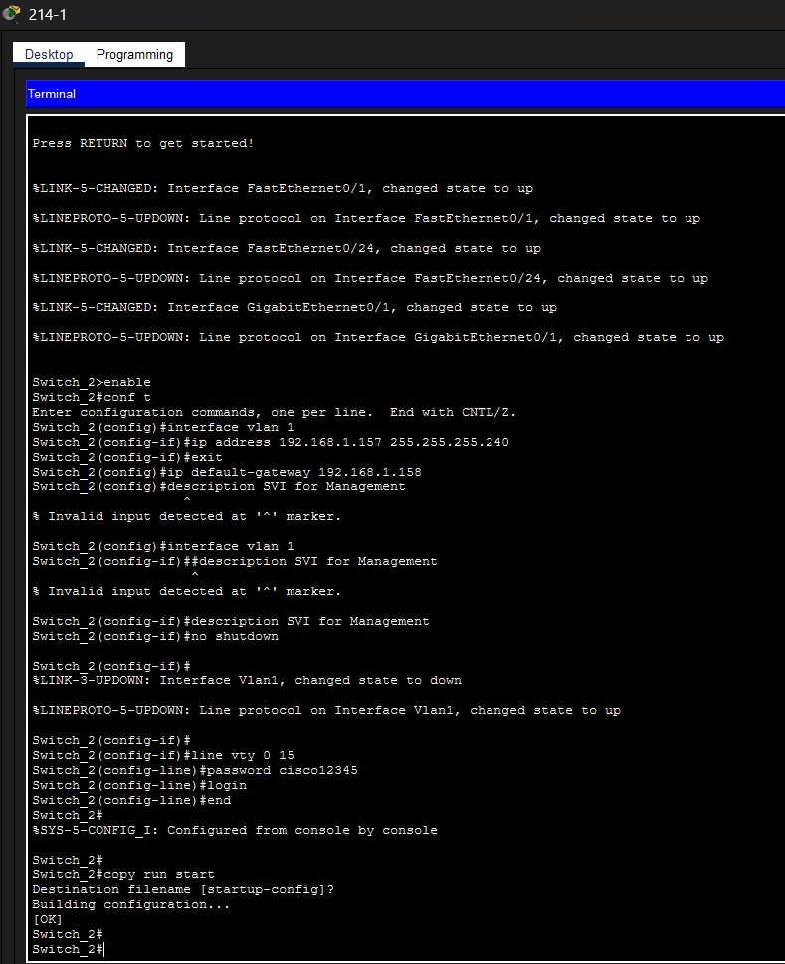
Figure 7. LAB 214-A Switch: VLAN 1 SVI, default gateway, VTY password, and the two invalid-command retries.
This switch only needs a management SVI and Telnet access; there is no routing here and no per-port VLAN work described in the assessment, so the configuration is short.
- interface vlan 1 then ip address 192.168.1.157 255.255.255.240 puts the SVI on the second-highest address of the LAB 214-A /28, as worked out in section 2.
- ip default-gateway 192.168.1.158 points the switch at the router's G0/1. A Layer 2 switch needs this so that management traffic to or from a different subnet (a remote Telnet session, for example) has somewhere to go, since the switch itself does not route.
- description SVI for Management was rejected twice before it went through: first because description was typed at the (config)# prompt after an exit had already left interface configuration mode, and second because of a stray ## at the start of the retried command. Once typed plainly inside interface vlan 1, it worked.
- no shutdown brings VLAN 1 up.
- line vty 0 15, password cisco12345, login enables Telnet with a password, satisfying "remote management over Telnet". There is no username/login local here, which is correct for Telnet-with-a-shared-password rather than the per-user SSH login used on the router.
- copy run start saves the configuration, confirmed by [OK].

6. Error reference
Device | Message | Cause | Fix
CS-Department | % Invalid input (ip ssh verison 2) | Transposed letters | ip ssh version 2
CS-Department | % Invalid input (ip address fe80::1 link-local) | Used ip instead of ipv6 | ipv6 address fe80::1 link-local
CS-Department | G0/1 IPv6 address typed as 2001:db8:acad:1::1/64 | Digit 1 instead of letter b | ipv6 address 2001:db8:acad:b::1/64
LAB 214-A Switch | % Invalid input (description ... at config prompt) | Typed after exit left interface mode | Re-enter interface vlan 1 first
LAB 214-A Switch | % Invalid input (##description ...) | Stray extra # typed | description SVI for Management

7. Things to check before submitting
- Fix the G0/1 IPv6 address. Change 2001:db8:acad:1::1/64 to 2001:db8:acad:b::1/64 so it matches the addressing table and the Server/214-1 network.
- Add the MOTD banner. The requirement list asks for one and it is not visible in the config screenshot: banner motd "Unauthorized access is prohibited" (or similar wording) in global configuration.
- Add a description to G0/1. G0/0 has "Connected to LAB 124-c Switch"; G0/1 does not yet have a matching description, e.g. "Connected to LAB 214-A Switch". The assessment asks for both interfaces to be documented.
- Move `security passwords min-length 10` earlier, or re-enter the enable secret and line passwords after it, so the rule is actually enforced on them rather than just happening to satisfy it.
- Verify SSH end to end with show ip ssh on the router and a Telnet attempt from a host to the router's VTY lines to confirm it is refused (only SSH should be accepted).
- Verify the switch is reachable from the other LAN by Telnetting to 192.168.1.157 from 214-1, the Server, or (once IPv6/IPv4 is confirmed) from across the router.
- `copy running-config startup-config` on the router — the switch screenshot shows this was already done there.
- Confirm end-to-end reachability: 124-1 and 124-5 to each other, to 214-1/Server (both IPv4 and IPv6), and to the router's own interfaces.

8. Verification commands
Command | What to look for
show ip interface brief | G0/0 and G0/1 up/up with the correct IPv4 addresses
show ipv6 interface brief | Both interfaces show the global and fe80::1 link-local addresses
show ip ssh | SSH enabled, version 2, RSA key present
show run | section line vty | VTY lines show login local and transport input ssh (router) or login with a password (switch)
ping (IPv4 and IPv6) | Between 124-1, 124-5, 214-1 and the Server, and to both router interfaces
telnet 192.168.1.157 | From a host on the other LAN, to confirm the switch accepts Telnet
ssh -l netadmin 192.168.1.126 | From a host, to confirm the router accepts SSH with the local account

Appendix: clean configuration
The commands from the screenshots with the typing mistakes removed and the fixes from section 7 applied.

CS-Department router

LAB 214-A Switch

Hosts and server (IP Configuration window)
Device | IPv4 | IPv6
124-1 | 192.168.1.97 / 255.255.255.224, gw 192.168.1.126 | 2001:db8:acad:a::ff/64, gw fe80::1
124-5 | 192.168.1.98 / 255.255.255.224, gw 192.168.1.126 | 2001:db8:acad:a::15/64, gw fe80::1
214-1 | 192.168.1.145 / 255.255.255.240, gw 192.168.1.158 | 2001:db8:acad:b::ff/64, gw fe80::1
Server | 192.168.1.146 / 255.255.255.240, gw 192.168.1.158 | 2001:db8:acad:b::15/64, gw fe80::1

